Test Case: tc005_SPX_Dev5_Crear_Requisicion_Spot_Con_FAD_Tipo_Cobro_Project
Step 1 - Enter username and password and click to button Enter: Credentials Entered
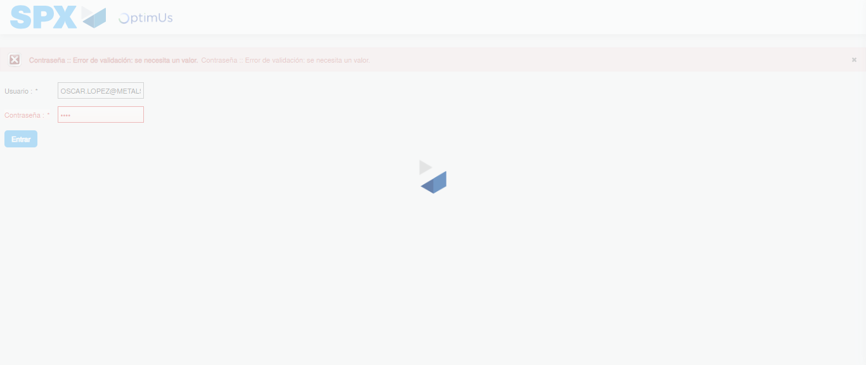Image file-name: QC_Testing-tc005_SPX_Dev5_Crear_Requisicion_Spot_Con_FAD_Tipo_Cobro_Project-1784573119828

Step 2 - Select to UEN and Access to Spot Buy Requisitions : UEN Correctly selected and Correct access
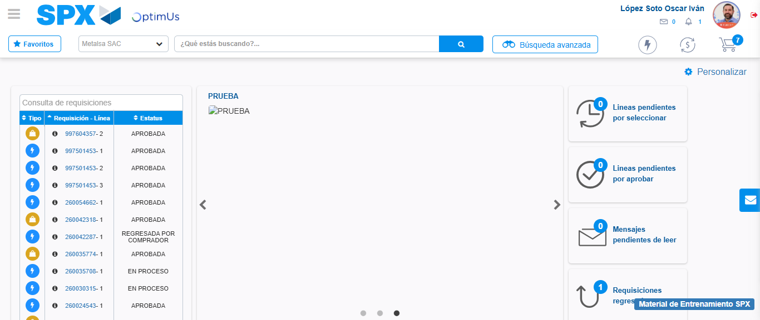Image file-name: QC_Testing-tc005_SPX_Dev5_Crear_Requisicion_Spot_Con_FAD_Tipo_Cobro_Project-1784573187459

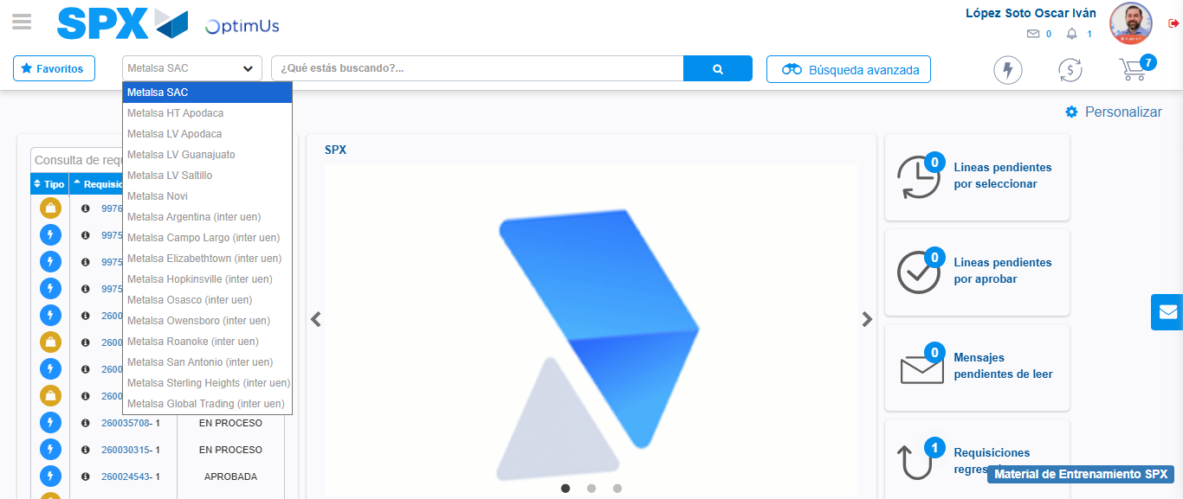Image file-name: QC_Testing-tc005_SPX_Dev5_Crear_Requisicion_Spot_Con_FAD_Tipo_Cobro_Project-1784573190194

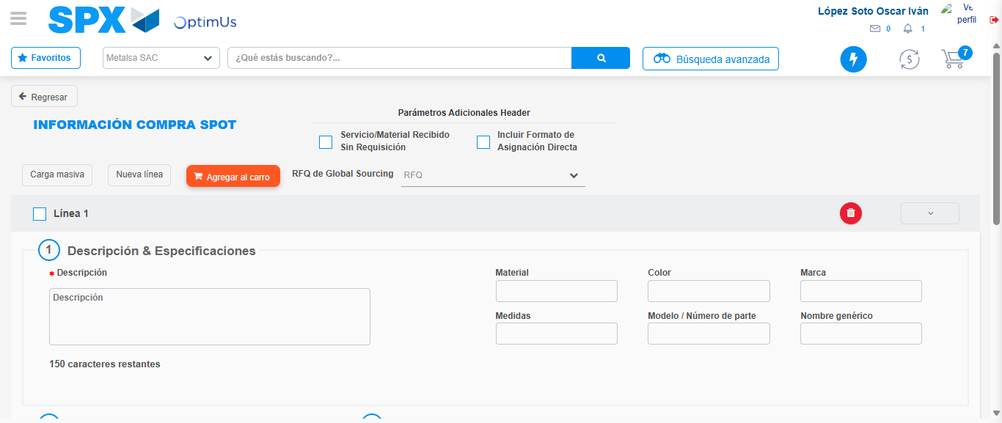Image file-name: QC_Testing-tc005_SPX_Dev5_Crear_Requisicion_Spot_Con_FAD_Tipo_Cobro_Project-1784573208729

Step 3 - Add FAD to Requisition: FAD Successfully Added
Image file-name: QC_Testing-tc005_SPX_Dev5_Crear_Requisicion_Spot_Con_FAD_Tipo_Cobro_Project-1784573208953

Image file-name: QC_Testing-tc005_SPX_Dev5_Crear_Requisicion_Spot_Con_FAD_Tipo_Cobro_Project-1784573209125

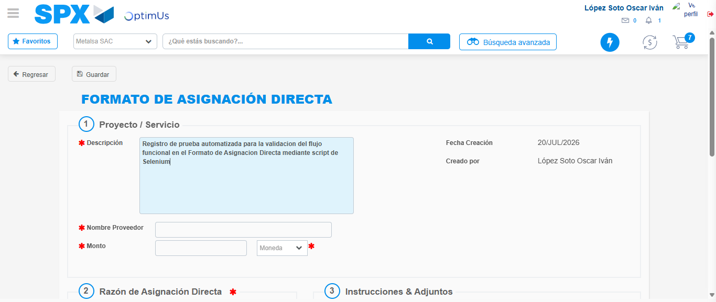Image file-name: QC_Testing-tc005_SPX_Dev5_Crear_Requisicion_Spot_Con_FAD_Tipo_Cobro_Project-1784573211891

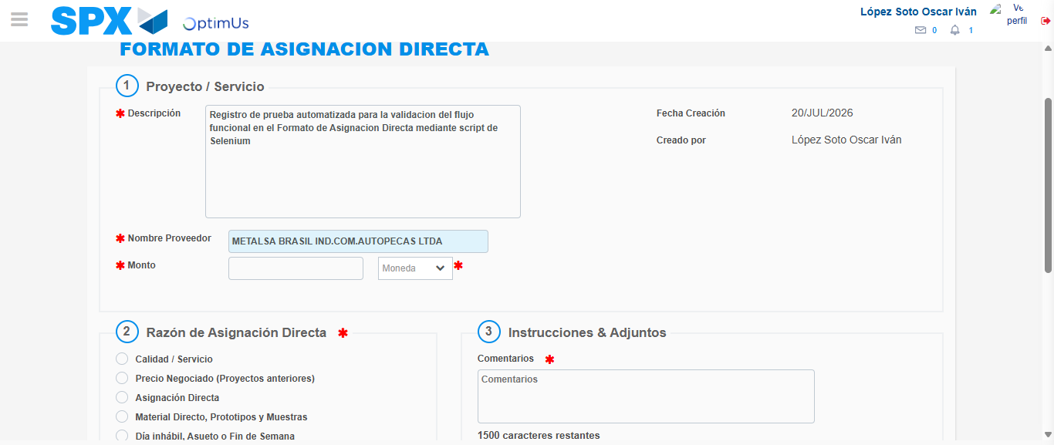Image file-name: QC_Testing-tc005_SPX_Dev5_Crear_Requisicion_Spot_Con_FAD_Tipo_Cobro_Project-1784573217778

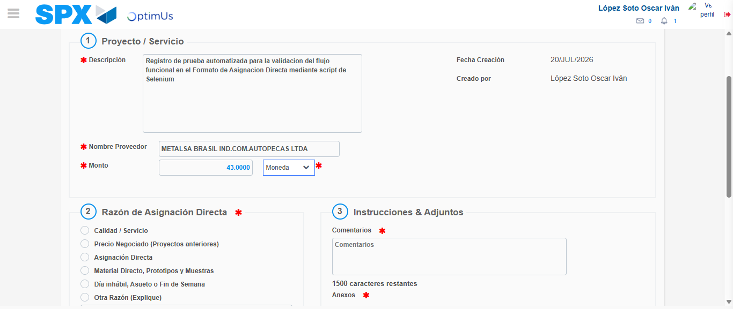Image file-name: QC_Testing-tc005_SPX_Dev5_Crear_Requisicion_Spot_Con_FAD_Tipo_Cobro_Project-1784573218165

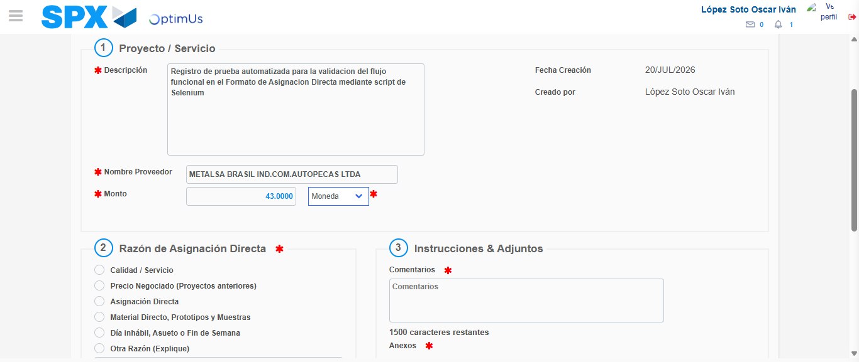Image file-name: QC_Testing-tc005_SPX_Dev5_Crear_Requisicion_Spot_Con_FAD_Tipo_Cobro_Project-1784573218362

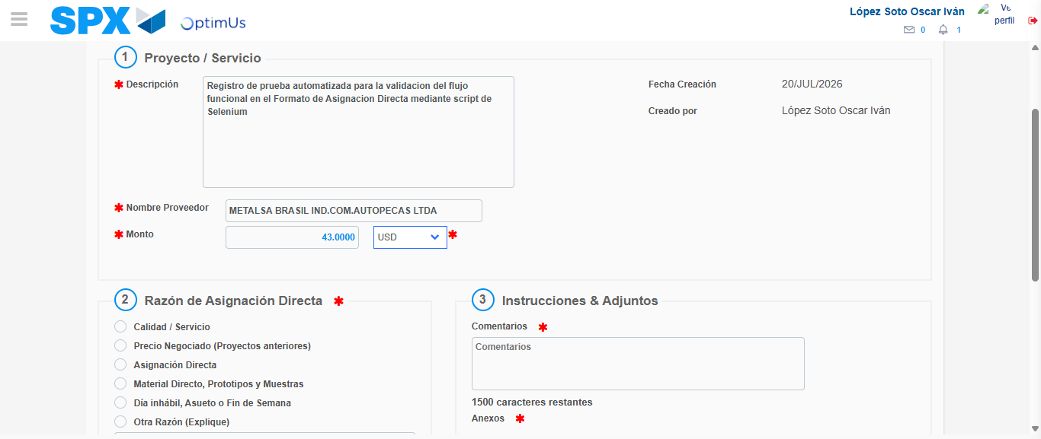Image file-name: QC_Testing-tc005_SPX_Dev5_Crear_Requisicion_Spot_Con_FAD_Tipo_Cobro_Project-1784573218671

Image file-name: QC_Testing-tc005_SPX_Dev5_Crear_Requisicion_Spot_Con_FAD_Tipo_Cobro_Project-1784573218879

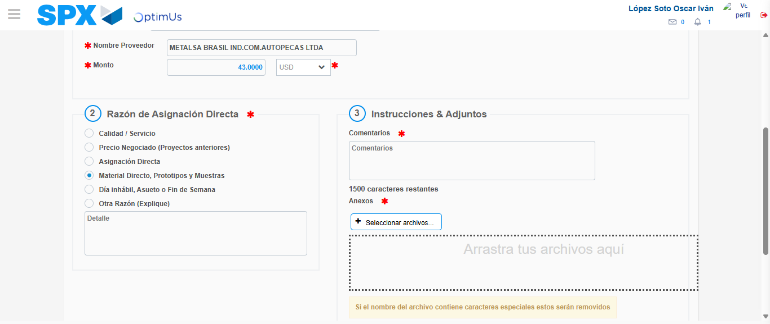Image file-name: QC_Testing-tc005_SPX_Dev5_Crear_Requisicion_Spot_Con_FAD_Tipo_Cobro_Project-1784573219689

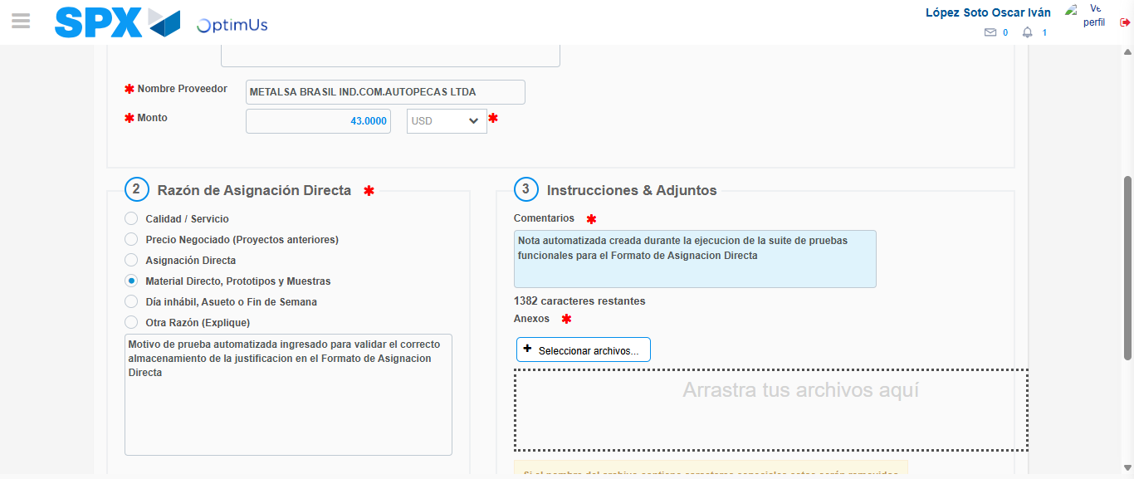Image file-name: QC_Testing-tc005_SPX_Dev5_Crear_Requisicion_Spot_Con_FAD_Tipo_Cobro_Project-1784573230741

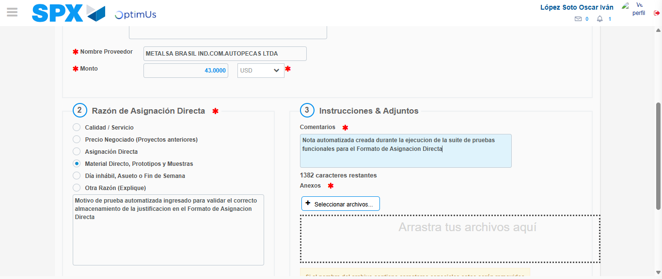Image file-name: QC_Testing-tc005_SPX_Dev5_Crear_Requisicion_Spot_Con_FAD_Tipo_Cobro_Project-1784573231335

Step 4 - Data Capture Spot Buy Requisition: Data captured correctly
Image file-name: QC_Testing-tc005_SPX_Dev5_Crear_Requisicion_Spot_Con_FAD_Tipo_Cobro_Project-1784573208953

Image file-name: QC_Testing-tc005_SPX_Dev5_Crear_Requisicion_Spot_Con_FAD_Tipo_Cobro_Project-1784573209125

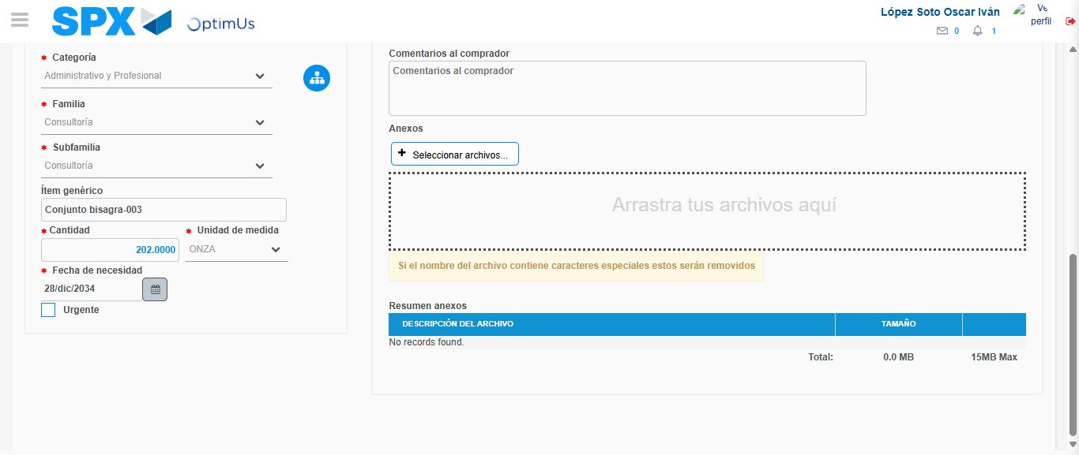Image file-name: QC_Testing-tc005_SPX_Dev5_Crear_Requisicion_Spot_Con_FAD_Tipo_Cobro_Project-1784573244695

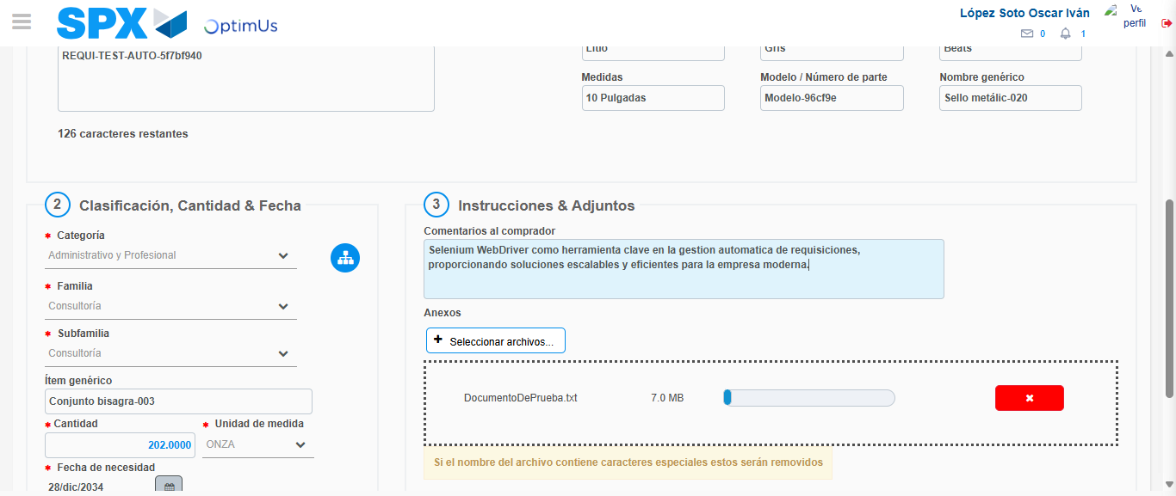Image file-name: QC_Testing-tc005_SPX_Dev5_Crear_Requisicion_Spot_Con_FAD_Tipo_Cobro_Project-1784573245429

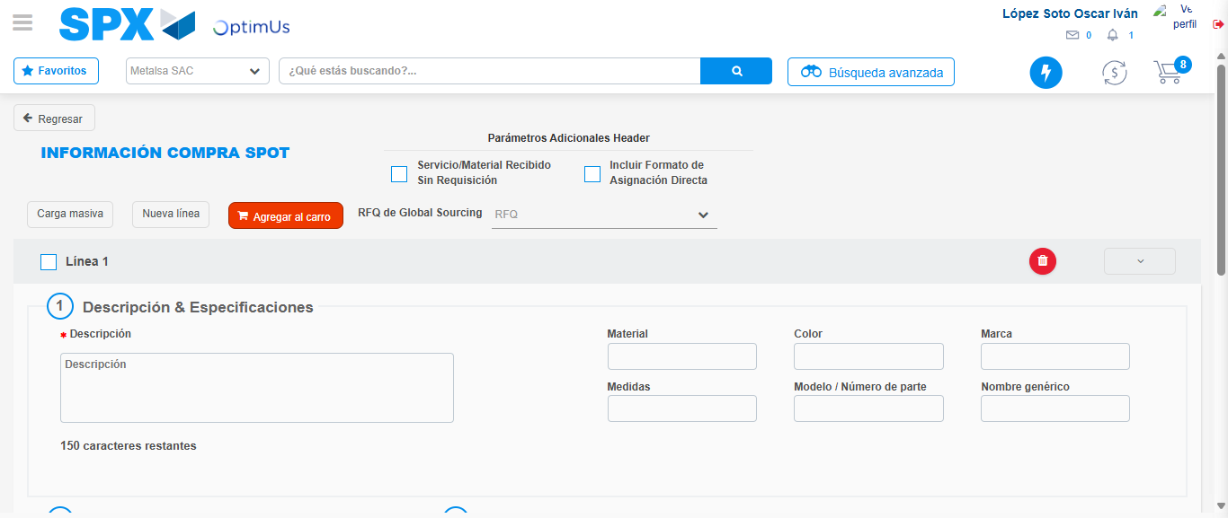Image file-name: QC_Testing-tc005_SPX_Dev5_Crear_Requisicion_Spot_Con_FAD_Tipo_Cobro_Project-1784573254448

Step 8 - Return to Main Page SPX : Return to Main Page SPX
Image file-name: QC_Testing-tc005_SPX_Dev5_Crear_Requisicion_Spot_Con_FAD_Tipo_Cobro_Project-1784573187459

Image file-name: QC_Testing-tc005_SPX_Dev5_Crear_Requisicion_Spot_Con_FAD_Tipo_Cobro_Project-1784573190194

Image file-name: QC_Testing-tc005_SPX_Dev5_Crear_Requisicion_Spot_Con_FAD_Tipo_Cobro_Project-1784573208729

Image file-name: QC_Testing-tc005_SPX_Dev5_Crear_Requisicion_Spot_Con_FAD_Tipo_Cobro_Project-1784573256645

Image file-name: QC_Testing-tc005_SPX_Dev5_Crear_Requisicion_Spot_Con_FAD_Tipo_Cobro_Project-1784573256806

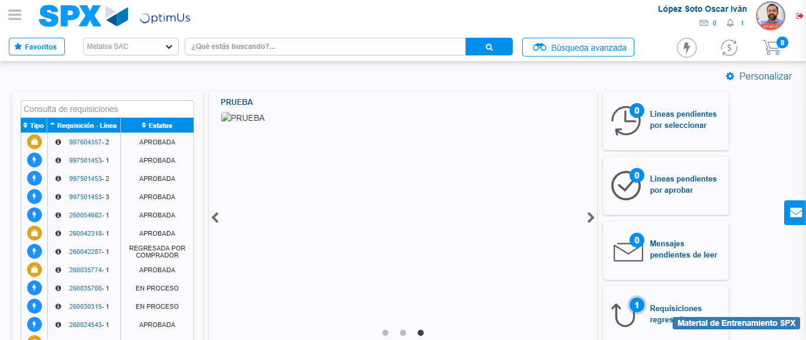Image file-name: QC_Testing-tc005_SPX_Dev5_Crear_Requisicion_Spot_Con_FAD_Tipo_Cobro_Project-1784573277808

Step 9 - Log Out : Log Out SPX
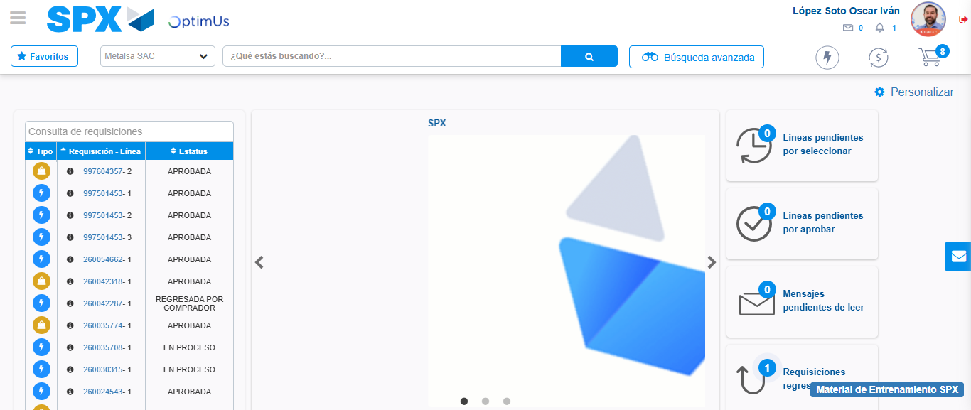Image file-name: QC_Testing-tc005_SPX_Dev5_Crear_Requisicion_Spot_Con_FAD_Tipo_Cobro_Project-1784573278091

